AZURE PROJECT

**TEAM-H**

TASK-2

**INTEGRATE GRAFANA (3rd party monitoring tool) to Azure Virtual Machine for Real Time Monitoring**

**Integrate Grafana (3rd party monitoring tool) to Azure Virtual Machine for Real Time Monitoring**

INTRODUCTION

*"Grafana is a powerful open-source monitoring and analytics platform widely used for visualizing and analyzing real-time data. Integrating Grafana with Azure Virtual Machines enables efficient real-time monitoring, helping track performance metrics and ensure system reliability."*

*[Type sidebar content. A sidebar is a standalone supplement to the main document. It is often aligned on the left or right of the page, or located at the top or bottom. Use the Text Box Tools tab to change the formatting of the sidebar text box.]*

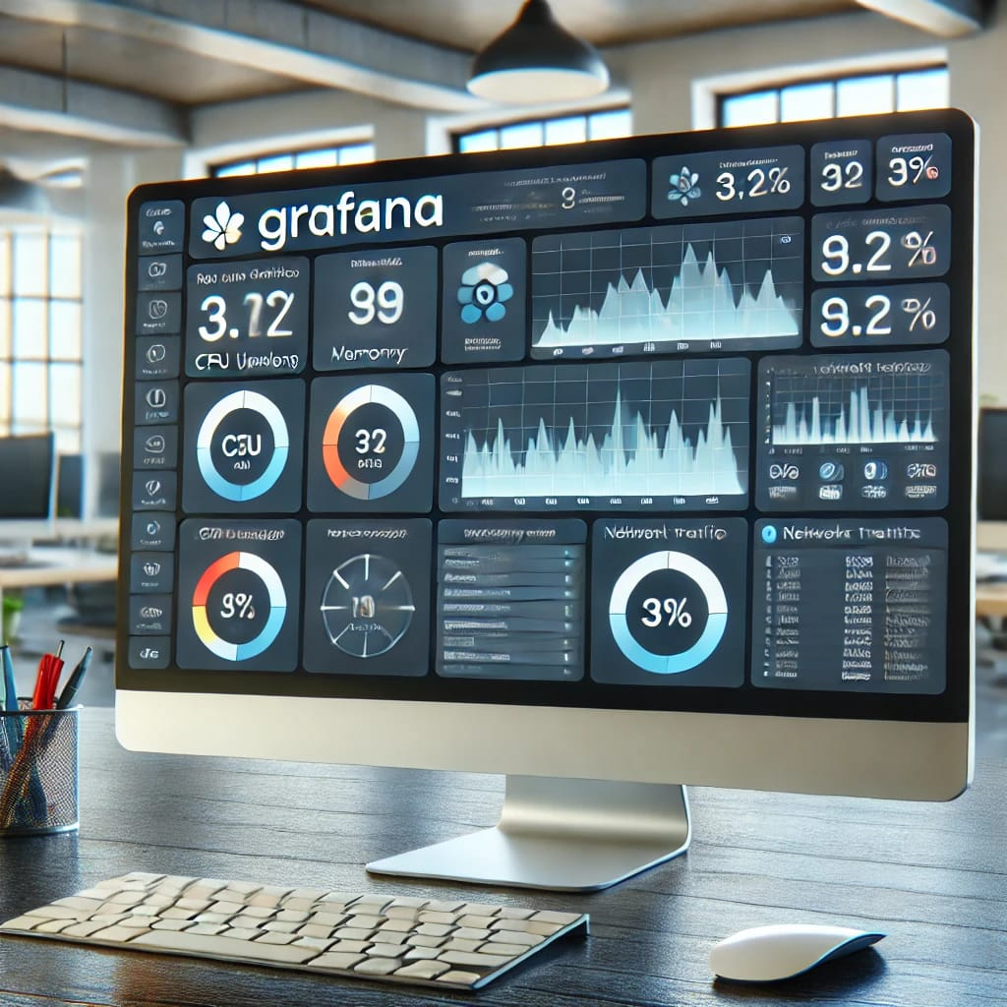

***INSTALLATIon***

*[Type sidebar content. A sidebar is a standalone supplement to the main document. It is often aligned on the left or right of the page, or located at the top or bottom. Use the Text Box Tools tab to change the formatting of the sidebar text box.]*

* For installation on Windows, Mac, and other flavors of Linux, please refer the official documentation of Grafana:
* <https://grafana.com/docs/grafana/latest/installation/>
* STEPS:

1. sudo apt-get install -y apt-transport-https

2. sudo apt-get install -y software-properties-common wget

3. wget -q -O — <https://packages.grafana.com/gpg.key> | sudo apt-key add –

4. echo “deb <https://packages.grafana.com/enterprise/deb> stable main” | sudo tee -a /etc/apt/sources.list.d/grafana.list

5. sudo apt-get update

6. sudo apt-get install grafana-enterprise

7. sudo service grafana-server start

8. sudo service grafana-server status

9. sudo update-rc.d grafana-server defaults

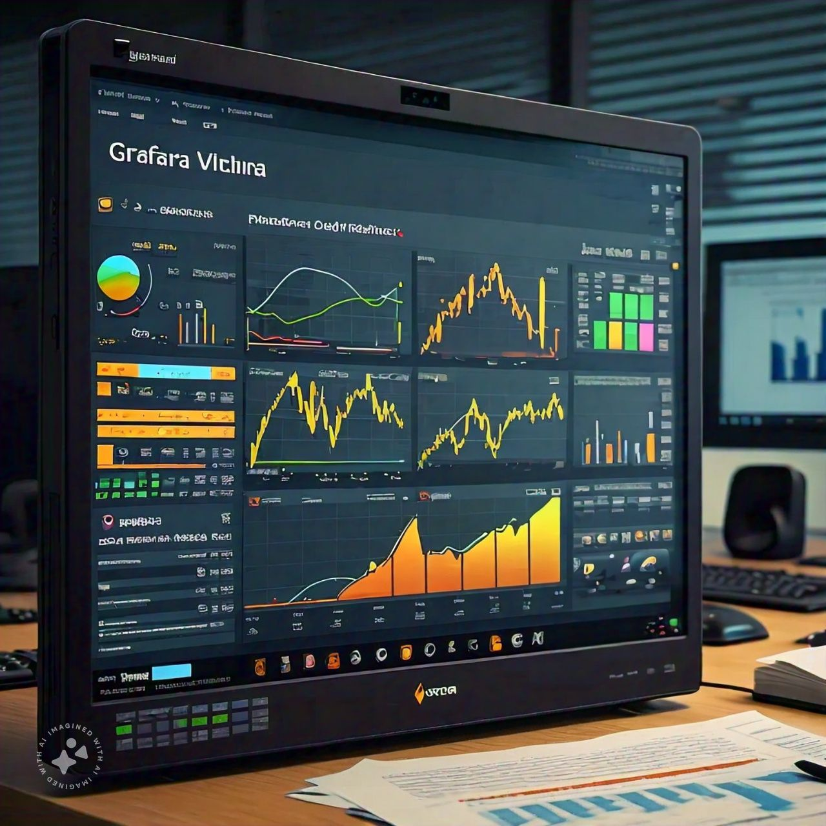

***Configuration***

*[Type sidebar content. A sidebar is a standalone supplement to the main document. It is often aligned on the left or right of the page, or located at the top or bottom. Use the Text Box Tools tab to change the formatting of the sidebar text box.]*

* Once the installation is complete open the Grafana tool on default port 3000
* **http://YOUR-IP:3000**
* Default username and password is admin which needs to be changed at first login.
* **NOTE**: Replace YOUR-IP with the public IP address of the VM where Grafana is installed

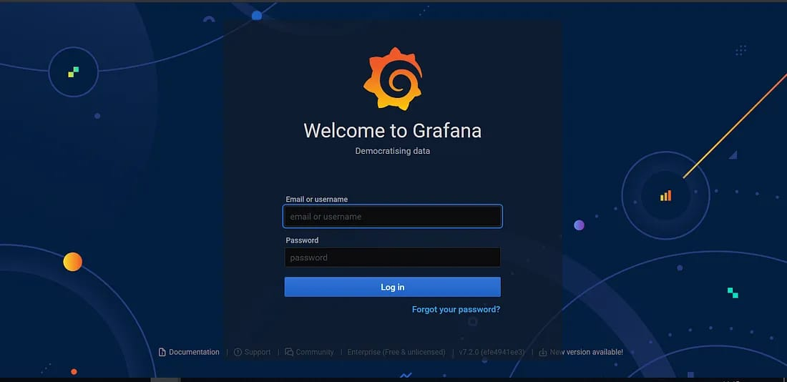

* Now we need to create a Service Principal and assign below permissions to the SPN:

**1.** Reader permission at subscription level

**2**. Log analytics Reader Permission for the subscription to read data from Azure log analytics.

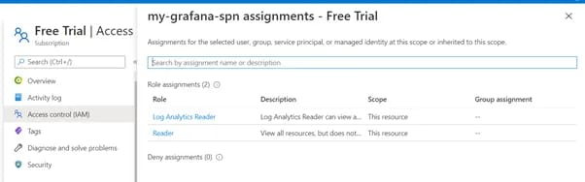

*[Type sidebar content. A sidebar is a standalone supplement to the main document. It is often aligned on the left or right of the page, or located at the top or bottom. Use the Text Box Tools tab to change the formatting of the sidebar text box.]*

**3.** Log analytics API permission. (Active Directory -> API Permission -> Add a permission)

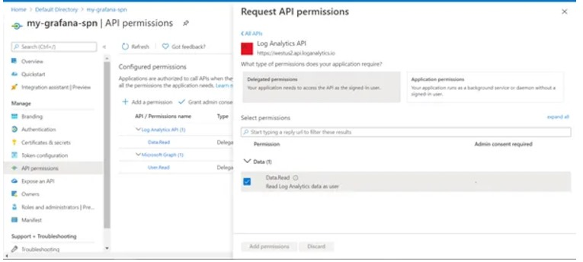

Once the SPN with required permissions is created, configure the Azure Monitor Data Source using the below steps:

***Datasource***

***1.Open the Grafana Instance on browser and go to Data Sources.***

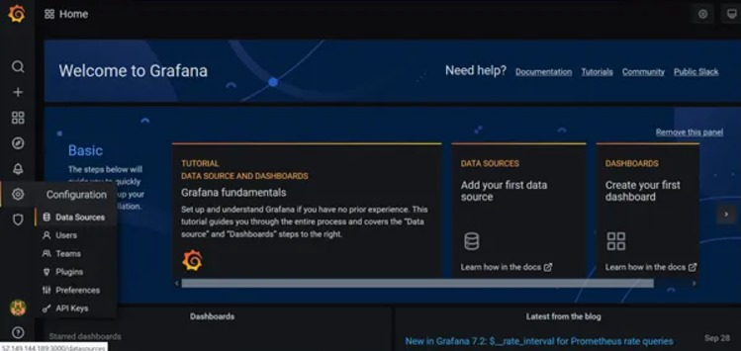

*[Type sidebar content. A sidebar is a standalone supplement to the main document. It is often aligned on the left or right of the page, or located at the top or bottom. Use the Text Box Tools tab to change the formatting of the sidebar text box.]*

***2.Click on Add data Source and search for Azure Monitor.***

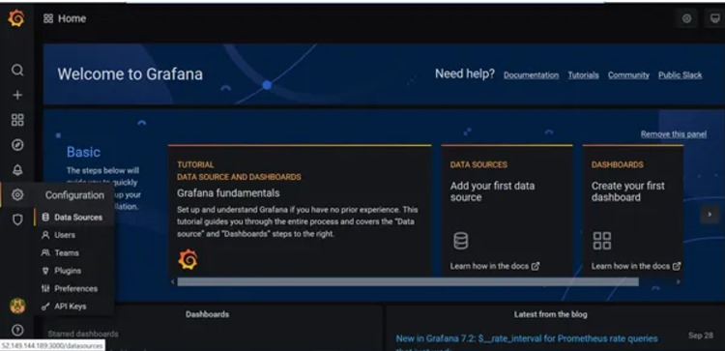

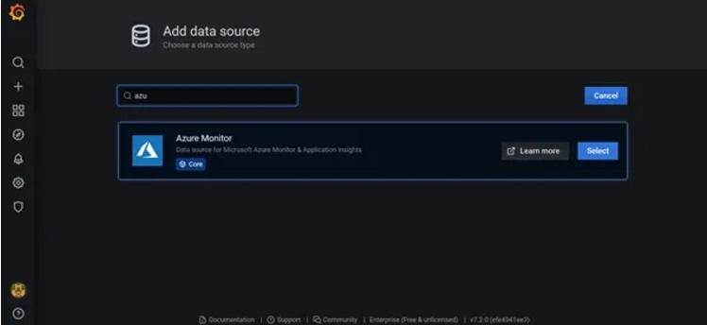

3.***Fill the details of SPN in the Data Source.***

*[Type sidebar content. A sidebar is a standalone supplement to the main document. It is often aligned on the left or right of the page, or located at the top or bottom. Use the Text Box Tools tab to change the formatting of the sidebar text box.]*

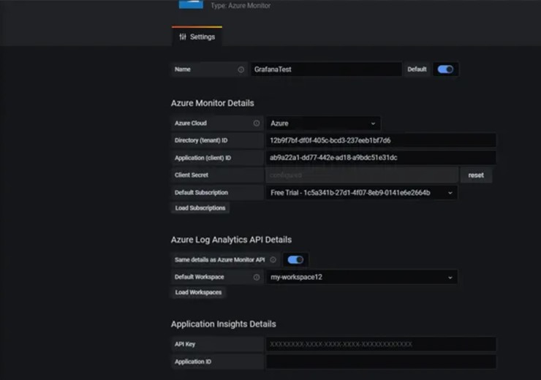

1. ***Now we have to create dashboard***

***Dashboards***

In this section I have created a dashboard using the data source configured in the previous section. It uses log analytics queries to fetch the data from perf table and display in Grafana. To list down the resource groups and VMs in those resource groups, we use a feature called as Variables which we can use in our log analytics queries.

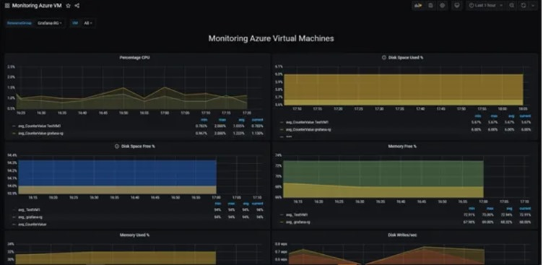

*[Type sidebar content. A sidebar is a standalone supplement to the main document. It is often aligned on the left or right of the page, or located at the top or bottom. Use the Text Box Tools tab to change the formatting of the sidebar text box.]*

*[Type sidebar content. A sidebar is a standalone supplement to the main document. It is often aligned on the left or right of the page, or located at the top or bottom. Use the Text Box Tools tab to change the formatting of the sidebar text box.]*

***For creating variables please use below screenshots:***

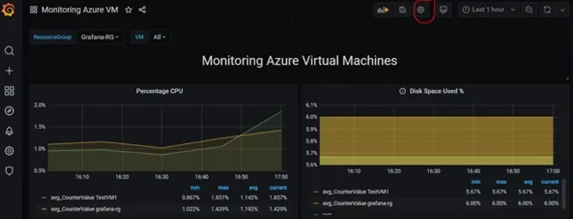

* **Create a variable ResourceGroup to list down all the RGs in the subscription:**

**ResourceGroups()**

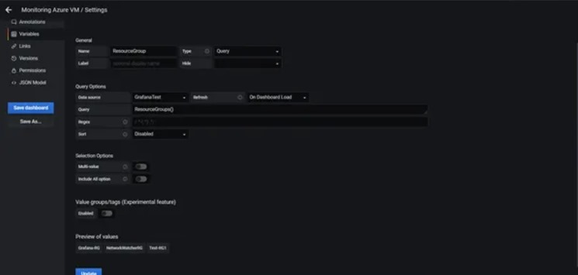

* ***Create variable VM to list down the VMs in RG:***

***ResourceNames($ResourceGroup,Microsoft.Compute/virtualMachines)***

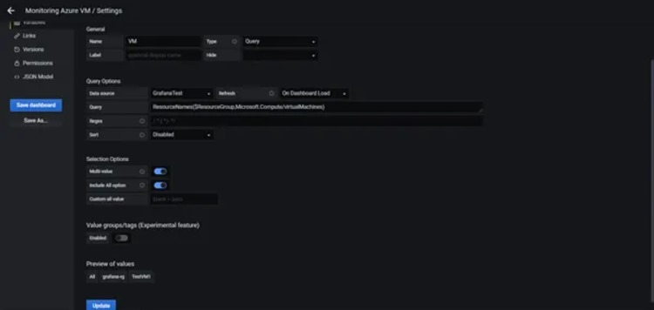

*[Type sidebar content. A sidebar is a standalone supplement to the main document. It is often aligned on the left or right of the page, or located at the top or bottom. Use the Text Box Tools tab to change the formatting of the sidebar text box.]*

***Now once the variables are ready, we can use them in our log analytics queries for various metric monitoring.***

*[Type sidebar content. A sidebar is a standalone supplement to the main document. It is often aligned on the left or right of the page, or located at the top or bottom. Use the Text Box Tools tab to change the formatting of the sidebar text box.]*

***Below are the few metrics which I used for monitoring Azure VMs:***

* **CPU Percentage(average): Displays the average CPU percentage for the last 5 mins**

**Variable VM is used in the log analytics to display data for all the VMs in the selected RG.**

Perf|where ObjectName ==”Processor” and CounterName ==”% Processor Time”|extend vm=iif(Computer has “.”,substring(Computer,0,indexof(Computer, ‘.’)),Computer)|where (tolower(strcat(“””,$**VM**,”””)) has tolower(vm)) and (Computer has vm)|where $__timeFilter(TimeGenerated)|summarize avg(CounterValue) by vm,bin(TimeGenerated,5m)| sort by vm asc , TimeGenerated asc| order by TimeGenerated asc

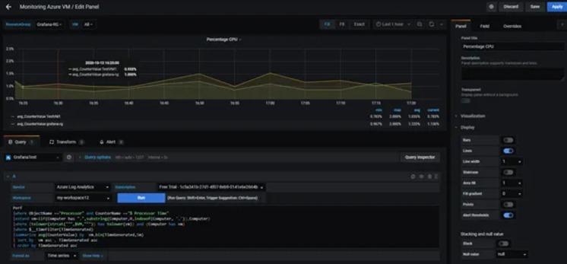

**The scale of X & Y axis can be changed from Axes panel as shown in the below screenshot:**

*[Type sidebar content. A sidebar is a standalone supplement to the main document. It is often aligned on the left or right of the page, or located at the top or bottom. Use the Text Box Tools tab to change the formatting of the sidebar text box.]*

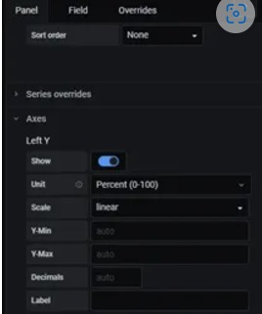

* **Disk Space Used (%): Displays the average disk space used in percentage on the VM for last 5 mins**
* Perf| where ObjectName == “LogicalDisk” or ObjectName == “Logical Disk”| where CounterName == “% Used Space”|where InstanceName != “_Total”|extend vm=iif(Computer has “.”,substring(Computer,0,indexof(Computer, ‘.’)),Computer)|where (tolower(strcat(“””,$VM,”””)) has tolower(vm)) and (Computer has vm)| where $__timeFilter(TimeGenerated)| summarize avg(CounterValue) by vm,bin(TimeGenerated,5m)| sort by vm asc,TimeGenerated asc| order by TimeGenerated asc

*[Type sidebar content. A sidebar is a standalone supplement to the main document. It is often aligned on the left or right of the page, or located at the top or bottom. Use the Text Box Tools tab to change the formatting of the sidebar text box.]*

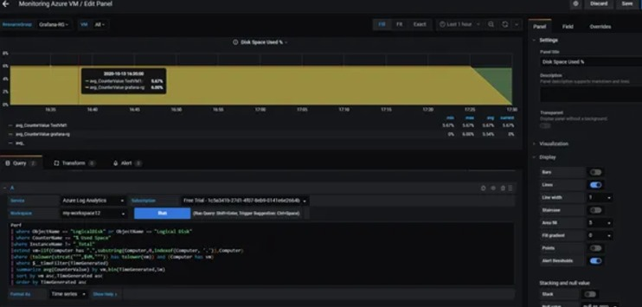

* **Memory Free (%): Displays the free memory (RAM) in percentage on the VM as an average of last 15 mins.**
* Perf|where ObjectName ==”Memory”|where CounterName ==”% Committed Bytes in Use” or CounterName == “% Used Memory”|extend vm=iif(Computer has “.”,substring(Computer,0,indexof(Computer, ‘.’)),Computer)|where (tolower(strcat(“””,$VM,”””)) has tolower(vm)) and (Computer has vm)| where $__timeFilter(TimeGenerated)|summarize avg(100-CounterValue) by vm,bin(TimeGenerated,15m)| sort by vm asc,TimeGenerated asc| order by TimeGenerated asc

*[Type sidebar content. A sidebar is a standalone supplement to the main document. It is often aligned on the left or right of the page, or located at the top or bottom. Use the Text Box Tools tab to change the formatting of the sidebar text box.]*

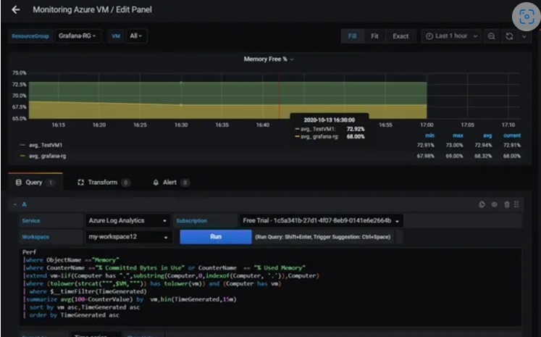

***CONCLUSION***

**Grafana provides a big set of plugins for integration with multiple cloud providers and other tools like Elasticsearch ,Graphite, Prometheus etc. Grafana also provides Reporting capabilities but it requires an Enterprise license. Grafana does not store any data which is a limitation but also good from a security point of view as it fetches real time data using REST API calls. So if you are looking for a centralized tool for monitoring of resources in multi-cloud environments or integration with other tools to improve visualization, Grafana is a good choice.**

**Thank You**

**By TEAM-H……!!**

*[Type sidebar content. A sidebar is a standalone supplement to the main document. It is often aligned on the left or right of the page, or located at the top or bottom. Use the Text Box Tools tab to change the formatting of the sidebar text box.]*